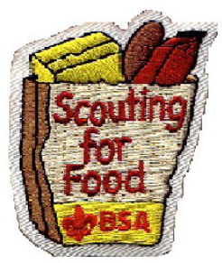
Dear Neighbor,

Hello. I am a Cub Scout with Pack 6 Crestwood.

Our Pack is collecting non-perishable food items THIS WEEK for our “Scouting for Food” drive. Would you like to help by donating a few items?

Here is how to donate:
Most Needed Food Items
All donations should be non-perishable No glass containers

- Tuna (canned, pouched)
- Peanut Butter
- Canned stews, soups, chili, and pasta
- Canned fruit
- Canned vegetables
- Whole grain low-sugar cereals
- Instant oatmeal
- Pasta and boxed macaroni & cheese dinners
- Rice
- Dried beans
- Leave one (or more) bags of non-perishable food outside your front door this _________ (day of week)
by ____ (time) with a note that says “Scouting for Food.”
- Contact Free/Leave Bag outside for pickup: I will pick up your donation from your front door on the day noted above.

Our Pack will bring the donations to the St. Joseph’s food pantry on Ashburton Ave in Yonkers.

We hope you will join us to help feed the hungry in our community.

Thank you!

Den __
Pack 6 Crestwood

Dear Neighbor,

Hello. I am a Cub Scout with Pack 6 Crestwood.

Our Pack is collecting non-perishable food items THIS WEEK for our “Scouting for Food” drive. Would you like to help by donating a few items?

Here is how to donate:
Most Needed Food Items
All donations should be non-perishable No glass containers

- Tuna (canned, pouched)
- Peanut Butter
- Canned stews, soups, chili, and pasta
- Canned fruit
- Canned vegetables
- Whole grain low-sugar cereals
- Instant oatmeal
- Pasta and boxed macaroni & cheese dinners
- Rice
- Dried beans
- Leave one (or more) bags of non-perishable food outside your front door this _________ (day of week)
by ____ (time) with a note that says “Scouting for Food.”
- Contact Free/Leave Bag outside for pickup: I will pick up your donation from your front door on the day noted above.

Our Pack will bring the donations to the St. Joseph’s food pantry on Ashburton Ave in Yonkers.

We hope you will join us to help feed the hungry in our community.

Thank you!

Den __
Pack 6 Crestwood

